About the workshop project demos
V1.2
There are two demos in this project:
- Demo in the workshop presentation time. It checks how well you present your software in a short time. It occupies 30% of the total presentation points. Refer to the syllabus and rubrics below.
Syllabus:
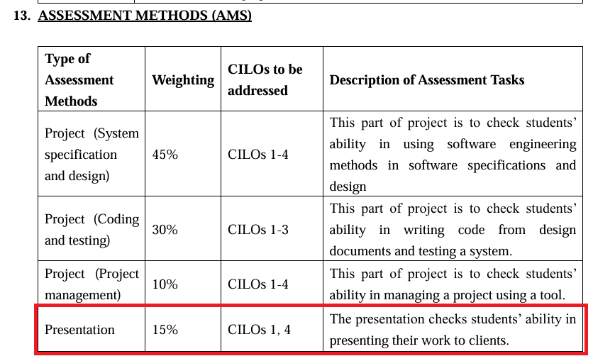
Rubrics for presentation:
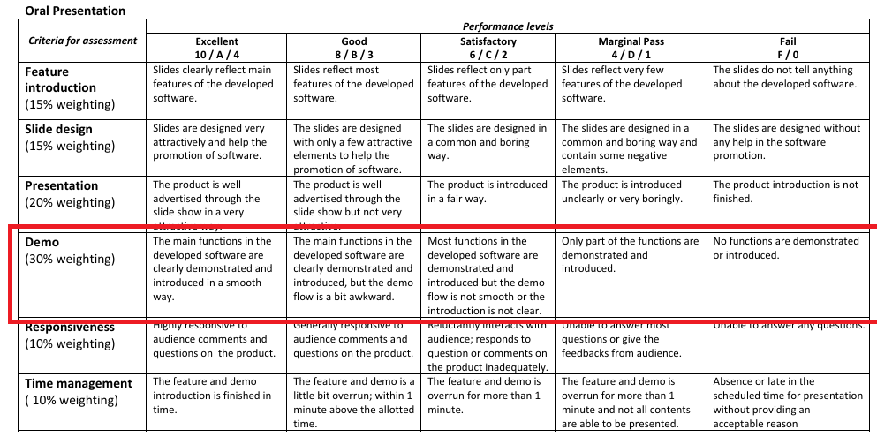

- Video demo. This video demo is used to check how many features have been implemented. We will provide you a checklist for you to prepare the video demo. You will upload video demo into iSpace for grading. The marks for video demo will be counted for Project Coding. Refer to the syllabus and rubrics below.

Syllabus:
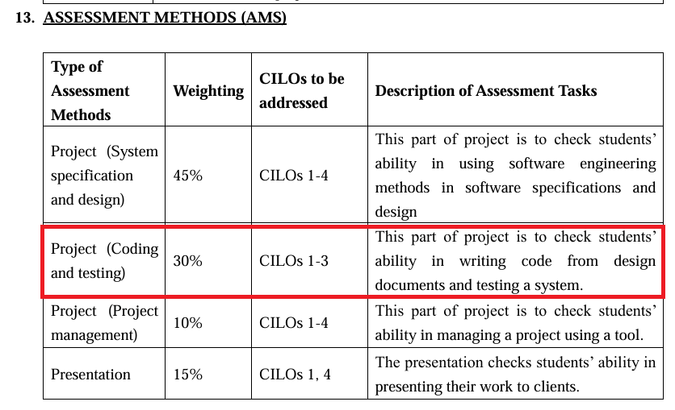
Rubric for video demo (Function implementation, coding):
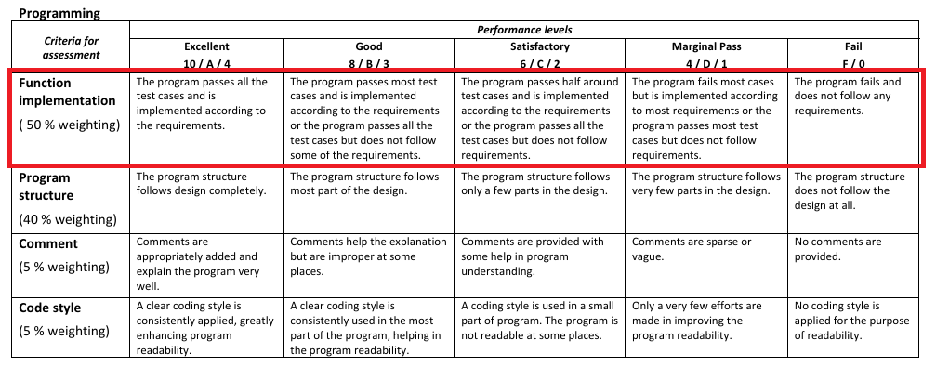
When you record video demo, please pay attentions here:
- Narrator's language: Chinese or English.
- When demo a feature, please give the index of the feature, for example, “现在 demo 5.4”.
- Please put down the time point that starting to introduce each finished feature in the excel file we provide you. The format will be like the following example. You are not required to demo in the sequence of checklist, but should demo clearly and smoothly.
Feature | Done | Start point in the video
- 1 | √ | 2:21
- 2 | √ | 0:50
- 3 | Χ
- 1 | √ | 1:12
- Video demo should not exceed 10 minutes.
- Don’t use mobile phone for recording. It will not be accepted.

